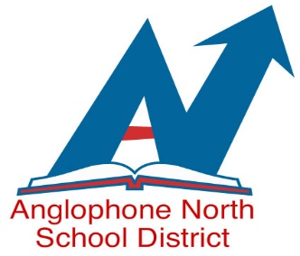
EMPLOYMENT OPPORTUNITIES
WE ARE AN EQUAL OPPORTUNITY EMPLOYER
CUPE 1253 MEMBERS

ANGLOPHONE NORTH SCHOOL DISTRICT
HOURLY SCHOOL BUS DRIVER
Temporary Position to June, 2019
With possibility of extension
Bus 170 –Rexton Area

Classification Specifications: As per attached job description.

Essential and Desirable Qualifications: As per attached.

Wage or Salary Rate: $20.28 per hour/Bus Driver (as of Oct. 1, 2018)

Hours of Work: Hourly driver – minimum of 6.5 hours daily or the time necessary to complete the assigned duties.

Bus Route – Bus # 170 Competition # 18-272

AM 1– 7:00 am St. Charles North Rd., Kent Lake area, St. Charles South Rd, Aldouane area and Richibucto area to
Rexton area Schools.

PM 1 – 2:00 pm Rexton area Schools for Richibucto area ,Aldouane area, St. Charles South Rd. St. Charles North Rd. and
Kent Lake South Rd.

PM 3 --3:00 pm Rexton area Schools for Richibucto area ,Aldouane area, St. Charles South Rd. Kent Lake area, St. Charles North Rd.

Posting Date: October 10, 2018

Closing Date: October 23, 2018

Apply To - Anglophone North School District
78 Henderson Street
Miramichi, N.B., E1N 2R7
Fax: (506) 778-6090 or email to: ASDNJobs@nbed.nb.ca

Please send a separate application for each position and include the competition number, your complete mailing address and phone number where you can be reached with your application.

