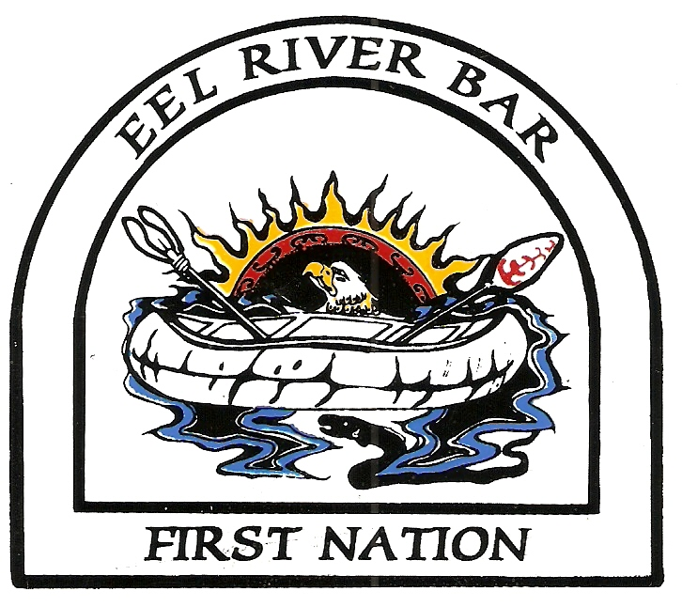
Enhanced First Nation Education Committee Proposal for Funding Form

Please submit proposals to: Eel River Bar Enhancement Committee via Matthew Sweezey

Deadline for Submissions:

Enhanced Agreement Educational Focus:
- To reduce the academic achievement gap that exists between First Nations’ students and non-First Nations’ students attending public schools in New Brunswick;
- To provide children of First Nations in New Brunswick with a welcoming school environment and a quality educational experience that is relevant and recognizes their cultural background; and
- To promote positive learning and working relationships between First Nations communities and School Districts.

Expenditure Guidelines:

- Establishment of a First Nation Education Enhancement Committee as per Appendix B of the Enhanced Agreement.

- All expenditure decisions will be based on proposals (see attached) for reinvestment mutually agreed upon by the First Nation Education Enhancement Committee and submitted to the Superintendent and Chief for approval.

- All expenditures must follow the purchasing and accounting standards that are in place for school districts in New Brunswick as outlined in the New Brunswick Public Purchasing Act and the Education Act.

- A financial statement will be issued to the First Nation Education Enhancement Committee /Community quarterly.

- Programs and services required under the Education Act are the responsibility of the school district to provide.

- A proposal to hire individuals to staff new initiatives must be submitted for approval to the First Nation Education Enhancement Committee. Once approved for hire by the Superintendent and Chief (or designate), new employees will report to the school district.

- Pupil transportation, transportation vehicles, and current or future capital improvement projects, in provincial schools or at the First Nations communities, are not covered by the Enhancement Agreement.

- Equipment purchases included in the Enhancement Agreement for home use or for use at First Nation communities are those that support programs such as after-school tutoring, homework programs, parenting programs, etc. and are property of the district to be utilized for First Nation support.

9. Extra/Co-curricular activities will be supported when possible through a mutually agreed process between the First Nation and the District.

10. Any investment of enhancement funds allocated towards activities that are above and beyond regularly funded federal and provincial programs and services as per the Plan of Establishment.

(Last Revised December 2015)
Eel River Bar First Nation/Anglophone North School District/Province of New Brunswick
Enhanced Educational Programs & Services Agreement
Proposal Funding Form
This form must be completed in-full along with your proposal and submitted to the Reinvestment Committee two (2) weeks prior to the next scheduled Reinvestment meeting.

The information provided on this form is a good-faith estimate of the information that will be contained in the final motion.

Proposal Submitted by:
Mailing Address:

Email Address:
School/FN Community

Title of Request

A presentation to the School District and Eel River Bar First Nation Education Committee may be requested upon completion of the project.
Project Coordinator:

Date(s): (Start and End)

Location:

Objective of Project:

How does this project support Strategic Action Plan Priorities for the identified First Nation Community:

Describe linkage to the education priorities:

Describe measurement of success for the proposed project/initiative: (How)

FUNDING REQUEST DETAILS
Specific Areas for Funding |  |  |  |  |  |  | Total Projected Cost
Request to Attend Workshop / Conference
 | # of Staff _________ |  |  | $ ____________ / person
 | Request for Training
 | # of Staff _________ |  |  | $ ____________ / person
Development of a New Position
# of positions ________ | $ ___________

 | Request to purchase resource or program material
 | Equipment _______ | Materials _________ |  |  | Supplies _______
Total Funding Requested:
Committee Approval By Consensus:

◻ First Nations ◻ District Office Date: _________________________________

Chairpersons Recommend the Above to be Considered for Funding:

_____________________________ _______________________________
First Nations Chairperson School District Chairperson
As duly authorized, we approve the above for funding under the Enhanced First Nations Education Programs and Services Agreement
_________________________________ _______________________________
First Nation Community Designate School District Designate

Date: Date:

