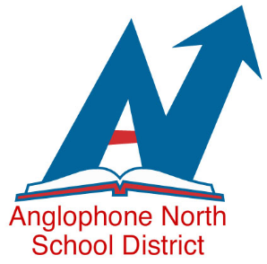
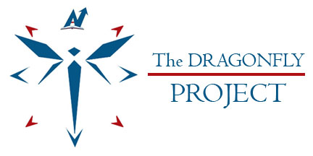
The dragonfly is an amazing creature. Born in the water, it begins to grow there but then moves into the air and learns to fly. The flight pattern of the dragonfly is incredible and with the ability to change direction quickly, it appears effortless as it glides through the air, demonstrating flexibility and adaptability. Its metamorphosis symbolizes transformation, maturity, change, clarity, power and joy.
Now you are probably wondering why the Superintendent is talking about a dragonfly and what exactly a dragonfly has to do with the work being done in Anglophone North School District. You may be thinking, “Well, she has finally lost it!” But please bear with me as I explain to you how the dragonfly’s can-do attitude symbolizes the direction we want our district to take.
Just like the dragonfly, Anglophone North School District has been working on a transformation. Since amalgamation, our Senior Management Team has been working on shaping the culture of the district - those values, beliefs and behaviors that are created by leaders in the organization and carried forward by employees, and that differentiate our school district from other districts across the province. As part of our work, we have established and are communicating the core values that we believe we need to respect, honor and live in order to build the strongest, most achieving and most vibrant organization that we can be, developing a culture that will support us in reaching our goals.

On November 4, 2016, a team of administrators, teachers and district staff met to begin work on a formalized cultural transformation of Anglophone North School District. The mandate of this committee is to build leadership capacity and to move culture change so that each and every one of us is at our best. The committee consists of the following staff:
Beth Stymiest - Superintendent
Craig Caldwell – Director of Schools and Co-Chair
Joan MacMillan – Director of Curriculum and Instruction
Anne Heckbert – Director of Human Resources
Judson Waye – Alignment Champion and Co-Chair
Tyson Theriault – Teacher, James M. Hill High School
Mary Lou Hudson – Vice Principal – Miramichi Valley High School
Dawn Beckingham – Principal – Dalhousie Regional High School
Jennifer Sullivan – Principal – Harkins Middle School
Carol Davis – Vice Principal – Bonar Law Memorial High School
Gilbert Cyr – Principal – Sugarloaf Senior High School

This cultural transformation team will meet each month to explore where we are and develop a plan of action to transform the culture of Anglophone North School District. This project, called The Dragonfly Project, is named for the dragonfly who carries the wisdom of transformation in life.
But the work of this committee will not be enough; we invite you to play an integral role in helping with this transformation. We know that this has been an extremely busy fall with the roll out of the new K-8 report cards, PowerSchool, the Integrated Services Delivery Model and the priorities of the new 10 year Ed plan. Focusing on our culture will not add to what we know is an already a full plate, but rather will help us be more efficient as we focus on our actions, behaviors and beliefs so we can better support each other, ensuring that our vision, mission and core values are the drivers for the way we do business.
Our goal is to become a learning centered organization where we:
- promote innovation
- celebrate high achievement
- learn from our mistakes
- take greater interest in our own personal growth and development
- solve problems confidently
- deal with workplace challenges competently
- question the status quo and provide suggestions for alternative solutions
Although we have pockets where this happens, this is not consistent or intentional practice across the district and we need to change this if we are going to become a high performing organization.
There is a renewed sense of urgency to get this right and to ensure that we are accountable for what has to change in our system. Having everyone at their best is very important in making and sustaining this change, and we need to encourage and support each other in our journey.
There are going to be many ways that you can be actively involved in bringing about this transformation. First of all, by living our core values, you will continue the journey that we have begun in moving the district forward. As well, we will be posting minutes from The Dragonfly Project committee meetings into a shared drive that all staff can see so that you can keep up to date on what is happening in the district. Suggestions and feedback are always welcome! There will also be opportunities for participation on action teams that have been established that will focus on three key areas:
- Leadership development
- Communication
- System levers for change.
We are excited about transforming the culture of Anglophone North School District. We know that our staff has much to offer and that with a few tweaks, we will have a school district that is strong, vibrant and focused on achievement, and that prepares staff and students for the future. We want this transformation to be like that of the dragonfly’s metamorphosis, a change that demonstrates our increased maturity, adaptability, and flexibility.

