Parent Guide :
- Click : http://asd-n.nbed.nb.ca/
- Click the Early Childhood tab on the main page

- Carefully read the consent form and click « Next ».

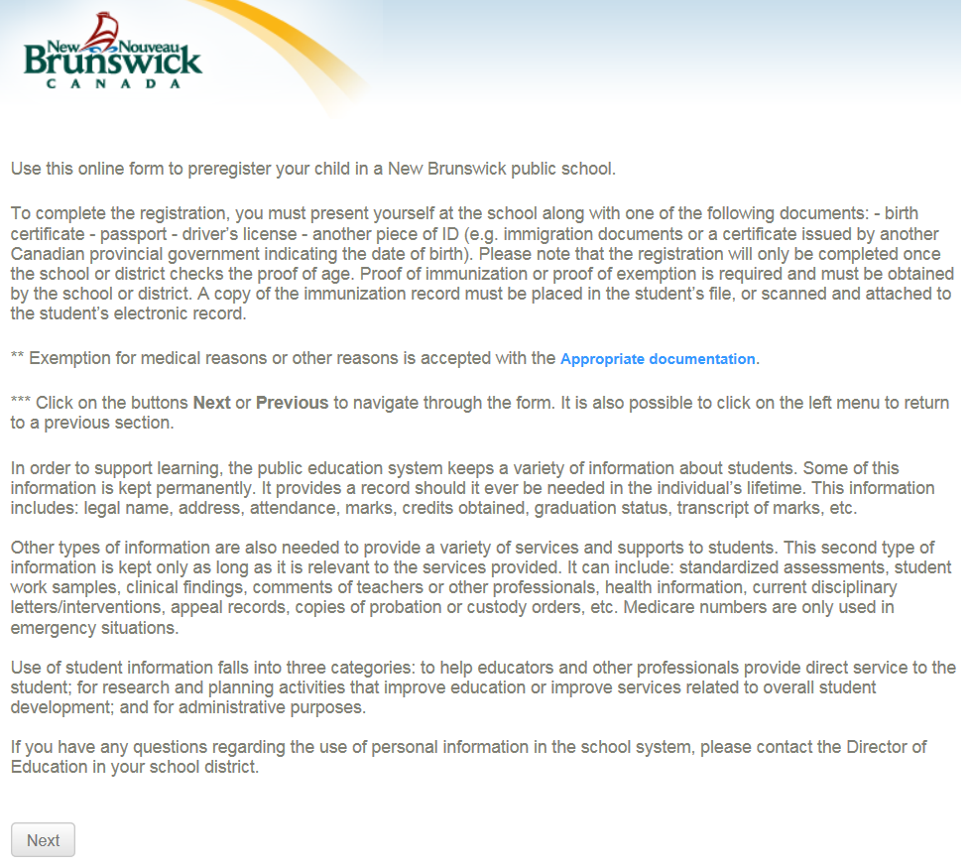

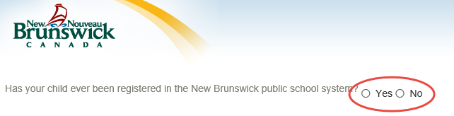
Answer the following questions :

- 2 choices :

If Yes;
If your child is already enrolled in a school in ASD-X, you don’t need to fill in the form. Just present yourself to the school to register your child.
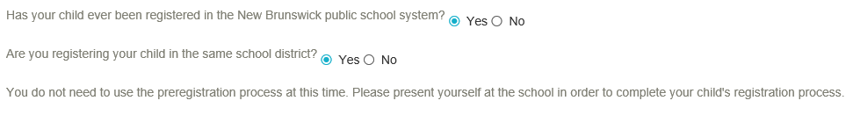

If No… Click the Launch Preregistration
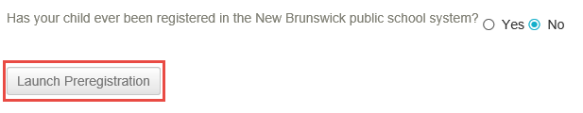

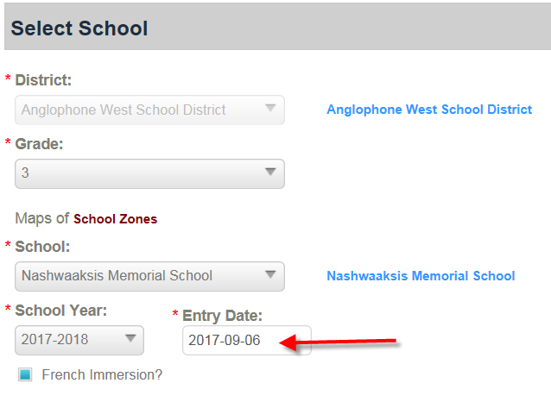
Select School
Fill in the information below:
- Grade Level:
- School: a list of schools offering the selected grade level will be displayed, select the school in your area**.
- School Year: Select the desired year of entry. (Select the next year for a preregistration)
- Entry Date: current date. (Preregistration students will default to the next year)
- French Immersion : check this box if your child will be entering a French Immersion program

** If you are unsure of the schools in your area, please contact the School Board Office in your district:
ASD-N – (506) 778 6075 ASD-E – (506) 856 3222
ASD-S – (506) 658 5300 ASD-W – (506) 453 5454

Select Previous School

If you select: This is the first entry to school then you can skip this page by clicking Next.

If this is not your child’s first entry in school, complete the required fields. Note that the province field is only applicable if you select Canada as the previous school country.

Click Next

Student’s General Demographics

Fill in the required information for your child’s registration:

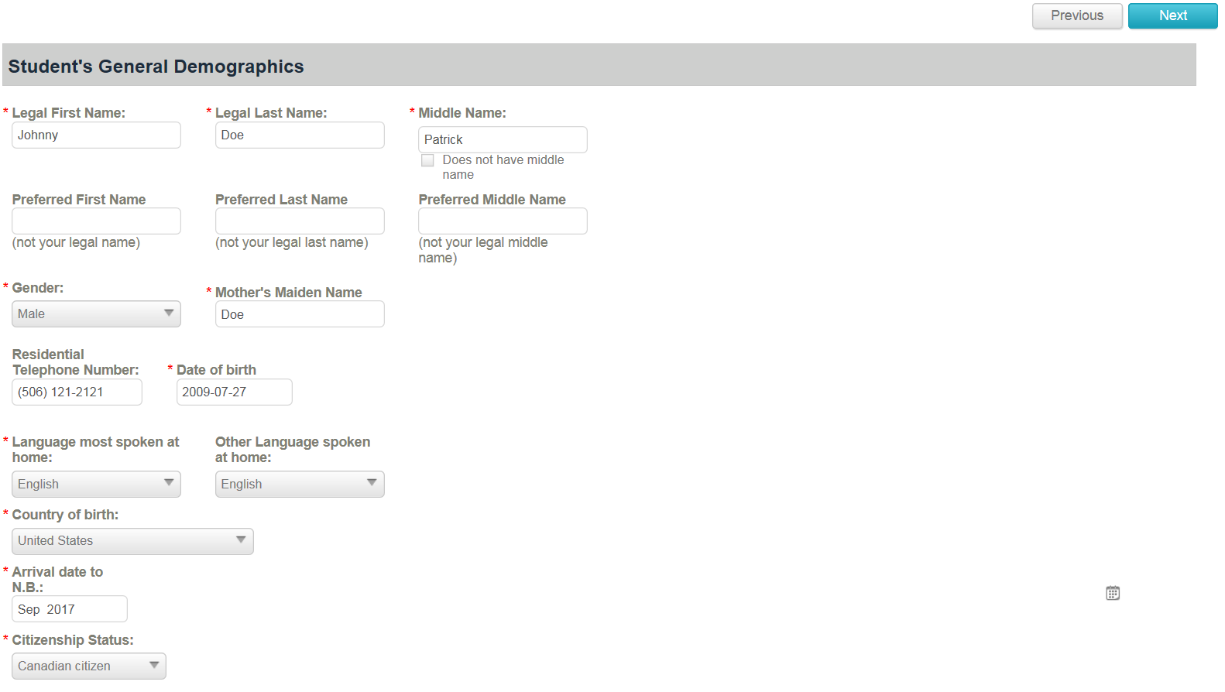

Click Next
Physical Address

If the mailing address is different than the physical address you need to select the option « Is mailing address different than physical address ».
Click Next

Student’s General Medical Information

The following information is not mandatory but should be filled out to help the enrollment process.

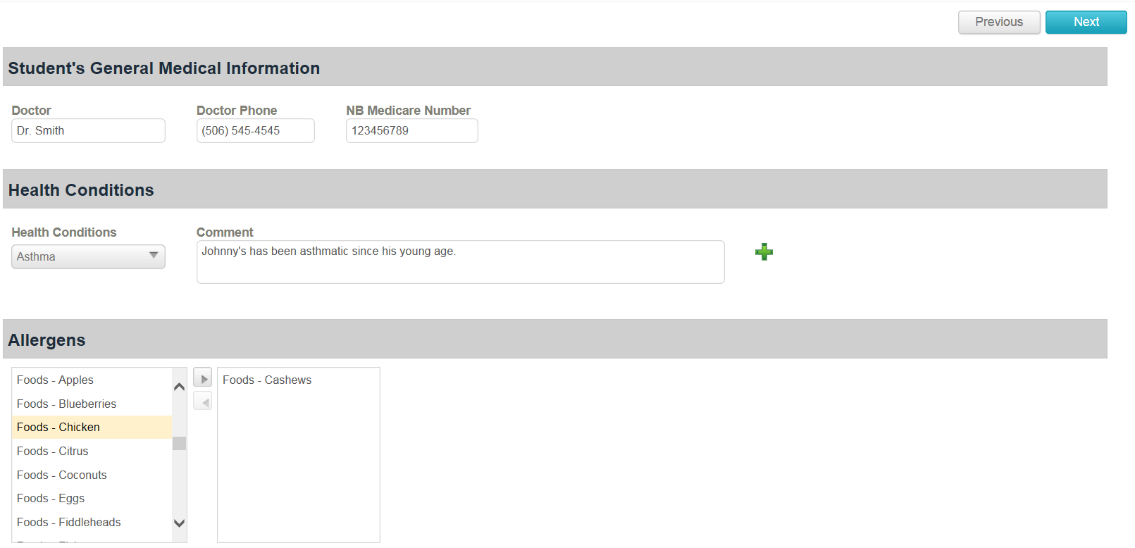

Click Next

Parents, legal guardians and other persons to contact in case of emergency

This page is used to capture all the student’s contact information in case of emergency. Fill in the contact and address information for a contact then click “Add Contact” to save the information. Afterwards you can enter additional contacts for your child. You can add up to 6 emergency contacts per child.

IMPORTANT – you must click Add Contact to save the contact information.

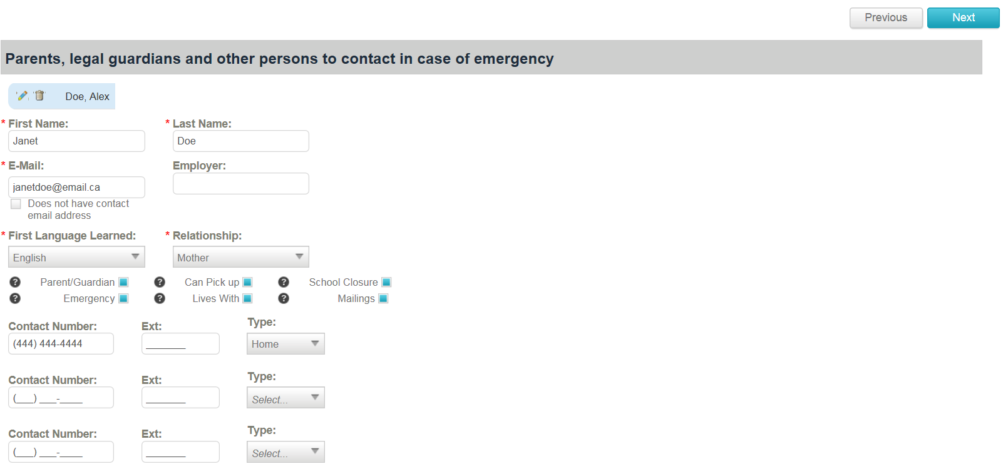
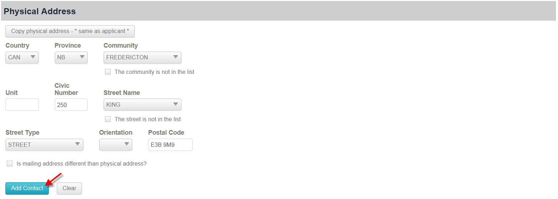

Once all contacts have been entered for your child, click Next.

Confirmation 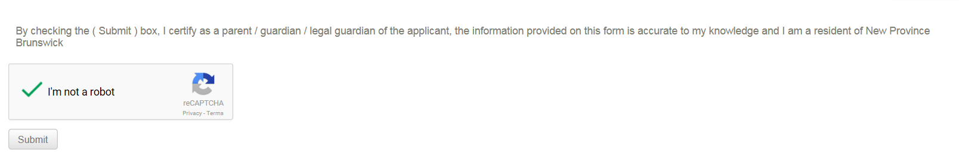
Click Submit to Preregister your child.

