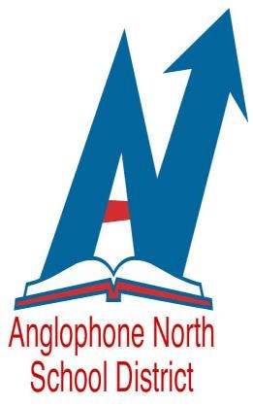
Act
WE ARE AN EQUAL OPPORTUNITY EMPLOYER

Anglophone North School District
Expression of Interest

Competition Number: 19-343

- Acting Vice-Principal, Dalhousie Regional School
January 27, 2020 – June 23, 2020 (with a possibility of an extension until February 2021)

Qualifications – (please include the following in your application):

- Covering Letter (quoting above competition number)
- Current Resume
- A valid N.B. Teacher’s License Certificate
- New Brunswick Principal’s Certificate or working towards Certificate
- Continuing Contract with Province of NB
- A minimum of five years successful teaching experience
- Proven leadership ability
- Two professional references

Please apply in writing to ASDNJobs@nbed.nb.ca by Friday, December 20, 2019.

