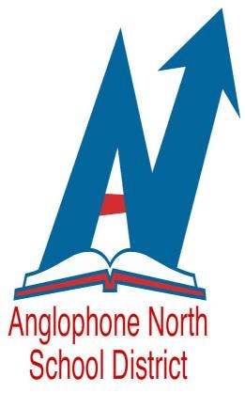
ANGLOPHONE NORTH SCHOOL DISTRICT
INVITES EXPRESSIONS OF INTEREST FOR THE FOLLOWING POSITIONS

September 2018 - June 2019 with the possibility of an extension

Competition # 18-101 - Numeracy Lead
- Dalhousie and Campbellton Area Schools

Competition # 18-102 - Gr. 1 & 2 French Immersion Lead
- Miramichi Area Schools

Qualifications and Experience

Applicants must possess a N.B. Teaching Certificate and have a minimum of five (5) years teaching experience. Knowledge of curriculum documents and resources, demonstrated experience collaborating with teachers, experience with and knowledge of inclusive practices, differentiation, and formative assessment are essential. Demonstrated leadership experience in facilitating professional learning and leading initiatives is a requirement for this position. Preference will be given to candidates who have demonstrated leadership skills, strong interpersonal skills, and effective communication skills. These qualifications must be clearly documented in a resume. Subject to the response of this posting, education and/or experience requirements may be changed.

Qualifications and Experience
- NB Teaching Certificate
- Minimum five (5) years teaching experience

Please forward your application to ASDNJobs@nbed.nb.ca by Noon on Monday, June 25, 2018.

Clearly indicate the competition number for the position you are applying for.

