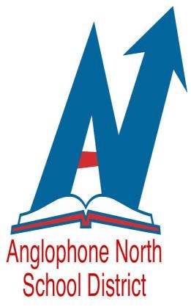

Anglophone North School District is accepting applications for the following Contract D and Long-Term Supply teaching positions.

Effective 2019-2020 School Year

Competition: 19-215: Bonar Law Memorial High School
- D Contract – August 26, 2019 – June 23, 2020
High School – FILA, History & PIF
French Immersion

Competition: 19-216: Blackville School
Grade 2 French Immersion – Long Term Supply
August 26, 2019 – December 20, 2019

Competition: 19-220: Bathurst High School
Long Term Supply – Grades 9-12 - August 26, 2019 – December 6, 2019
PIF, French Immersion

Qualifications:
- Bachelor of Education & appropriate French oral proficiency

Please forward your application to ASDNJobs@nbed.nb.ca by Friday, August 16, 2019 at 4pm.

