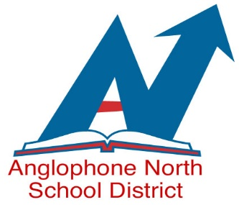
EMPLOYMENT OPPORTUNITIES
WE ARE AN EQUAL OPPORTUNITY EMPLOYER
CUPE 1253 MEMBERS

ANGLOPHONE NORTH SCHOOL DISTRICT
HOURLY SCHOOL BUS DRIVER
Temporary Position Bus 399
Until May 1, 2019 with the possibility of extension
Bathurst Area

Classification Specifications: As per attached job description.

Essential and Desirable Qualifications: As per attached.

Wage or Salary Rate: $20.28 per hour/Bus Driver (as of October 1, 2018)

Hours of Work: Hourly driver – minimum of 6.25 hours, or the time necessary to complete the assigned duties.

Bus Route – Bus # 399 Competition # 19-011

AM 1 – 7:00 am Rio Grande Road, Middle River Road, Scenic, Maple to Terry Fox and Bathurst High and transfer to other busses for Superior Middle School

PM 1 – 1:45 pm Vantassell, Vanier, Sunset, Msgr. Godin and Valle Lourdes from Superior Middle School

PM 2 - 3:05 pm Vantassell, Vanier, Sunset, Msgr. Godin from Superior Middle School

PM 3 – 3:20 pm Receive transfers at BHS from TFS and SMS to Garden St, Evangeline, Middle River Road and Rio
Grande Road

Posting Date: February 12, 2019

Closing Date: February 26, 2019 @ 4:00 pm

Apply To: Anglophone North School District
78 Henderson Street
Miramichi, NB E1N 2R7
Fax: 506-778-6090 Or email to ASDNjobs@nbed.nb.ca

When applying for competitions, please include the following information:

    - First and Last name
    - Competition number
    - Complete Address
    - home and cell number
    - Permanent or casual employee if applicable
    - Current job location if applicable
    - If including your resume, please send as an attachment

