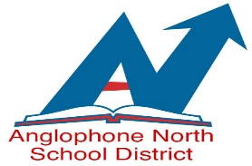
Early Education and Early Childhood Development
RENEWAL for a Local Permit: For Supply Teaching
School District: ASD-North School Year: 2021-2022
APPLICANT INFORMATION: (Please Print)
Surname: | First Name:
Address: | Telephone #:
City: | SIN#
Province: | Postal Code:

Previous Local Permit (Please circle): Yes or No

Current Local Permit in another District (Please circle): Yes or No
If Yes: District #, Year & level: ____________________

POST SECONDARY TRAINING
Institution | Program (BA, B.Sc, Etc) | Dates | Degree or Diploma

IMPORTANT: Please attach an evaluation fee of $40.00 in the form of a money order payable to Minister of Finance, Province of NB.
School Year Ending: 2022

______________________________ _______________________________ __________________________
Applicant Signature Evaluator Signature Date of Evaluation

______________________________ ________________________________
Superintendent Signature Date

OFFICE USE ONLY
Entered Excel AESOP Scanned

Please Return; Att: ASD – N Tanya Quigley
78 Henderson Street, Miramichi, NB E1N 2R7 506-778-5344

