Making a human medicine wheel
Divide students into four groups each representing a direction. Have students discover, either by the direction of the sun or using a compass, where each cardinal direction is. The north group will go first forming a straight line from the center spot, pointing north. Likewise, the other groups will follow suit. Once students have formed the cardinal lines of this medicine wheel with their bodies, go around the have each group state the direction they represent and are facing. Have each person make a statement about something they see facing their direction ( ex. When I face west I see the church steeple). Have each group indicate where the sun is in relation to the direction they are facing.

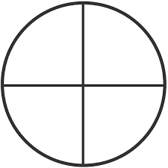
The four groups will end up like the spokes of a wheel pointing north, south, east and west. Have a note taker in each group write down the direction and what distinguishing landmarks lie there. (Ex. When we face west we see…. and note landmarks.) Write down the season and where the sun is in relation to their view. Why was it important to have good observational skills when living off the land?
Have students continue to stand with their groups and gradually form a large circle with the whole class holding hands. This large circle encompassing all directions and all people is the medicine wheel. It represents the seasons of the year, the ages of life, races of people on earth, four parts of health and the four elements.
North: winter, air, elderly, white skinned people, mental health
East: spring, fire, infancy, yellow skinned people, emotional health
South: summer, water, youth, red skinned people, spiritual health
West: autumn, earth, adults, black skinned people, physical health

Understanding that these are of equal value and importance and part of the whole will help them gain understanding of the interrelationships of all things that the Medicine wheel symbolizes.
*Lesson can expanded on by inviting a Mi’kmaq Elder or traditionalist to the school to learn more about the inter-relatedness of Mother Earth and humans.

Adapted from Ethnobotany: Patterns in Relationships written and complied by Illene Pevec, MA

