Professional Learning Session - Our Youngest Learners: Using Reflective Practice In Infant Programming

During the week of June 24- 27th there were 4 professional learning sessions held during the evening for educators and directors across our region. In total 43 educators came together to discuss current practices and to reflect on what changes they would like to make within their own centers.
Sessions were offered in Dalhousie, Bathurst, Miramichi and Rexton in a response to feedback received from educators that it is much easier to attend sessions when they are held ‘close to home’.

The focus of the session was infant and toddler programming using a reflective practice approach. Participants were introduced to the educator portfolio and provided those in attendance with a binder and other materials to begin their portfolio. There was also a wonderful discussion of next steps, as well as what can be added as they continue in this process of building a community of practice for our region.

As co-learners, educators were asked to reflect on what they considered to be the role of learning within the spaces they create each day. A few of the questions we discussed together as a group were
- What is our image of an infant / toddler?
- How does our image effect our planning?
- How are you purposeful in what you do each day?
- What evidence is there to support this?
- What is one thing you will do different tomorrow?

Educators were encouraged to share one thing they would like to do different, and how they thought they could make this change.

We were very grateful to be able to distribute materials provided to us (see picture below) by Explore Literacies NB as door prizes to educators participating in the professional learning session.

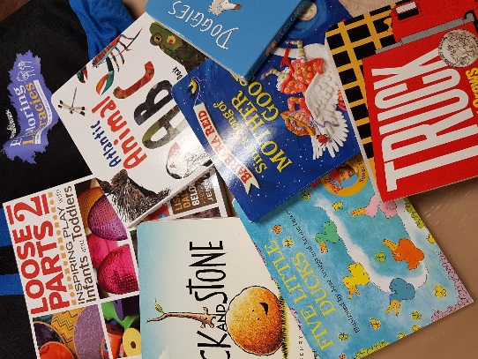

Disappointed you missed this session? Sign up now for our next session being offered in August!

SAVE THE DATE!
Music and Movement For Transitions
Using Reflective Practice with the New Brunswick Curriculum Framework for Early Learning and Child Care~ English

Richibucto: August 6th
Miramichi: August 7th
Dalhousie: August 13th
Bathurst: August 14th
All sessions will be from 6:30 – 8:30 pm

More information regarding guest speaker and location will be emailed to all Early Learning and Care Centers and educators on our email list. A certificate for 2 hours of professional learning will be provided for educators in attendance.

For more information or to register, please contact Shelby Goodin at 624-2040 or by email at Shelby.Goodin@gnb.ca

Here’s a sneak peek at our door prize for this session:

