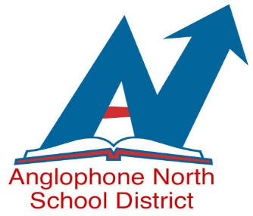
EMPLOYMENT OPPORTUNITIES
WE ARE AN EQUAL OPPORTUNITY EMPLOYER
Anglophone North School District

Invites applications for the following Teaching Position

Competition Number: 19-330

North & South Esk Regional School
- Contract D – Effective Immediately until June 23, 2020
- 1st Semester - Post-Intensive French (PIF) Grade 8 & 9
Personal Development & Career Planning Grade 10
Culinary Tech 110

- 2nd Semester - PIF Grade 8 and 10
Entrepreneurship
Culinary Tech 110

Qualifications as follows must be included with your application:
- N.B. Teacher’s Certification
- French Certification Level

Please apply to ASDNJobs@nbed.nb.ca with a cover letter indicating competition number by Monday, November 18, 2019 at 4:30pm.

