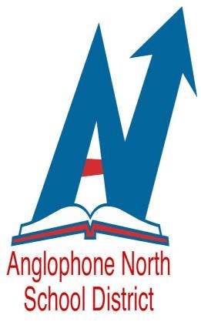
WE ARE AN EQUAL OPPORTUNITY EMPLOYER

Anglophone North School District
New Brunswick, Canada
Invites applications for the following positions:

Competition Number: 19-273
- School Psychologist I or II (C & Y Team)
Miramichi Area Schools

Competition Number: 19-274
- School Psychologist I or II (C & Y Team)
Bathurst, Dalhousie and Campbellton Area Schools

Child and Youth Team:
The C&Y ISD team provides integrated assessment and intervention services to children, youth and families with identified multiple needs as defined by the 5 core areas of development (health and wellness; emotional and behavioral functioning; family relationships; educational development and mental health). This service is based on an Integrated Service Delivery framework that includes the collaboration of the Departments of Health, Education, Social Development and Public Safety. C&Y teams are comprised of Addiction and Mental Health clinicians (social workers, clinical psychologists and nurses), school psychologists, school social workers, community support workers and Education Support Teachers - Guidance and Education Support Teachers – Resource.

School Psychologist:
This position is a re-assignment whereby the NBUPPE contract will be adhered to and employees will remain under Education. This position is responsible for the timely and effective provision of services to children, youth and families as defined by the Integrated Service Delivery Framework. The School Psychologist will provide intervention, assessment, and crisis response support to enhance the social-emotional and behavioral development of children and youth. As a member of an inter-disciplinary, inter-departmental team, the School Psychologist will be an integral part of collaborative problem-solving teams and contribute to the educational community within an inclusive and RTI service delivery model.
This position will provide a broad range of professional psychological services in the school system in the application of the science of psychology to the areas of student learning and behavior, assessment and evaluation, understanding of child and adolescent exceptionalities and psychological adjustment.
Qualifications:
A Masters or Doctoral degree in Psychology with course work to meet the requirements for licensed membership in the College of Psychologists of New Brunswick. Experience in child psychology is desirable. The successful candidate must be capable of working both independently and in a collaborative manner with students, parents, teachers, Integrated Service Delivery and Education Support Services Teams. Knowledge of school-based decision-making and policies would be an asset.

Salary:
In accordance with the New Brunswick Union of Public and Private Employees (Professional Support Group) Collective Agreement, $2 560.76 - $3 265.29 Bi-weekly (@ June 30, 2018)

Please forward your resume indicating education and experience to ASDNJobs@nbed.nb.ca by Friday, September 27, 2019 at 4pm.

