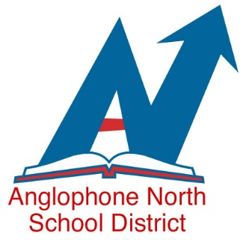

Kindergarten Registration for September 2022 school year.
Attention all parents of children born in 2017:

Due to Corona Virus protocol, Kindergarten registration for September 2021 in Anglophone School District North will be changing. This year, the first step to register your child for Kindergarten is to contact your community school by telephone between September 20th and October 8th to make an appointment for an in-person meeting at the school.
At the time of your appointment, you will come to the school to complete registration requirements, provide copies of your child’s birth certificate, proof of immunization and Medicare card. In-person registration appointments will occur between October 12th to the 22rd between 8:30 and 3:00 pm. Please note that no access to the building without a scheduled appointment will be permitted. All health and safety guidelines are in place in ASD-N. All visitors to our schools must wear a community mask upon entering our buildings and follow all Public Health protocols.

.

