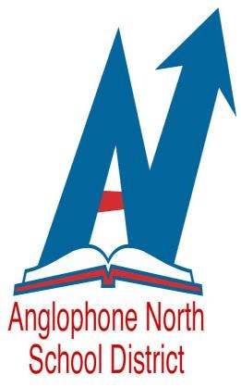
WE ARE AN EQUAL OPPORTUNITY EMPLOYER

Anglophone North School District
New Brunswick, Canada
Invites applications for the following positions:

Speech Language Pathologist I (Talk With Me Program)

Competition #20-104

​Position: Temporary - Speech Language Pathologist I
.9 FTE (4.5 days per week - total of 32.6 hours per week)
Location: Bathurst Area
Start/End Date: Immediate – August 6, 2021​

This is an open competition; however, in accordance with the NBUPPE Collective Agreement- Professional Support Group, should unionized employees under this bargaining group apply, employees shall be selected based on skill, ability and qualifications. Where skill, qualifications and ability are relatively equal amongst union applicants, the vacancy will be filled based on seniority. If there are no union applicants, the position will be filled from qualified applicants for these competitions.
​
This is professional work in the field of speech language pathology. Employees of this class perform primarily preventative work with limited clinical work, according to professional standards and district/provincial policies and procedures. This may involve screening, identification, assessment, interpretation, diagnosis and initial, rehabilitation services for children aged birth to five. The primary focus of this positive will be prevention of communication disorders and promotion of language and communication strategies. Work performed is oriented to client and family needs and may require active participation on interdisciplinary teams, consultation on client waitlists, determination of service delivery options, ongoing assessment and discharge readiness determination. Work may be performed on behalf of school district but within community-based settings.
Work includes participation in planning and implementation of program activities, and may include quality improvement, performance management and statistical activities, child/parent education and research and may include caseload management and care coordination. Work may include relieving the superior in his/her absence and supervising support personnel. Work is performed independently and is reviewed by a superior. Employees of the Speech Language Pathologist classification may be required to provide clinical supervision of delegated function (tasks/activities) to rehabilitation therapy assistants, guidance, training and orientation to other speech language pathology staff, students and other professionals.
These job duties are the basic and prime duties of the job; related and allied duties may be assigned from time to time as may become necessary to the operation of the service.

Qualifications:
- Master’s degree in Speech Language Pathology.
- Registered and a member in good standing with the New Brunswick Association of Speech Language Pathologists and Audiologists and eligible for membership with the Canadian Association of Speech Language Pathologists and Audiologists.
- Written and spoken competence in English is required.
- Two References (current Supervisor in a related field)
​Salary:
In accordance with the New Brunswick Union of Public and Private Employees (Professional Support Group) Collective Agreement, $2 312.60 - $2 912.14 Bi-weekly (90% of full wages) (@ June 30, 2018).

The posting will remain open until December 2, 2020 with a possibility of an extension.
Apply at: http://asd-n.nbed.nb.ca/human-resources or directly at Apply To Education.

Thank you in advance for applying. Only those selected for an interview will be contacted.

