Water and its Importance
Pre-teaching would involve learning about the importance of water. The students will walk to the local river and give thanks for the water. If possible have an elder come to do a small water ceremony to give thanks to the water, learn about the importance of water and why we must protect our waters. In First Nation culture it is important to always give thanks and to protect the land and waters for future generations.
If possible read the book, “The Elders Are Watching” by David Bouchard and Roy Henry Vickers.
(Elizabeth Price has a copy, just email her and she will get it out to you)
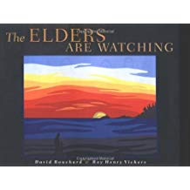
The students can also create displays in the school and become water protectors themselves. The local rivers are very important river to us all. Also, possibly extend the lesson by doing a cleanup in one section of the riverside. The students can create lists of all the things they find and do a chart and report it to the local government and possibly ask the local government to do another cleanup on a larger scale. The students can research out what type of living things use the local river and what is going to happen if the river isn’t taken care of.

Lesson ideas created by Patricia Miller

